Topic 4.5

COMPOUNDS CONTAINING THE CARBONYL GROUP

Aldehydes and Ketones
Carboxylic Acids and their Salts
Esters
Acyl Chlorides and Acid Anhydrides

ALDEHYDES AND KETONES

1. Introduction

Aldehydes and ketones are collectively known as carbonyls and represented by the general formula C_{n}H_{2n}O. They have the following functional group:

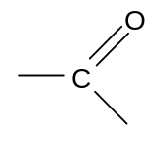
In aldehydes one of the groups attached to the carbon is a hydrogen atom and the other is
a hydrogen atom or an alkyl groups. In ketones both of the groups attached to the carbon are alkyl groups:

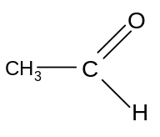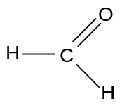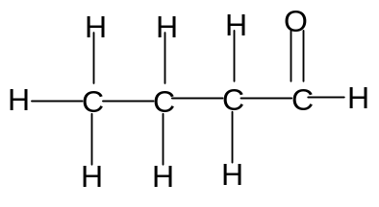
ethanal methanal butanal

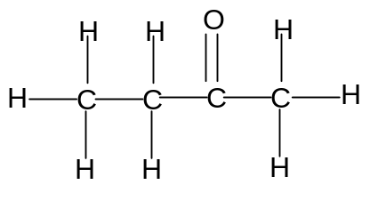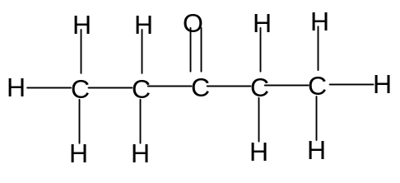
butanone pentan-2-one
2. Redox reactions

The redox reactions involving carbonyls have been discussed at AS level and are summarized by the following diagram:

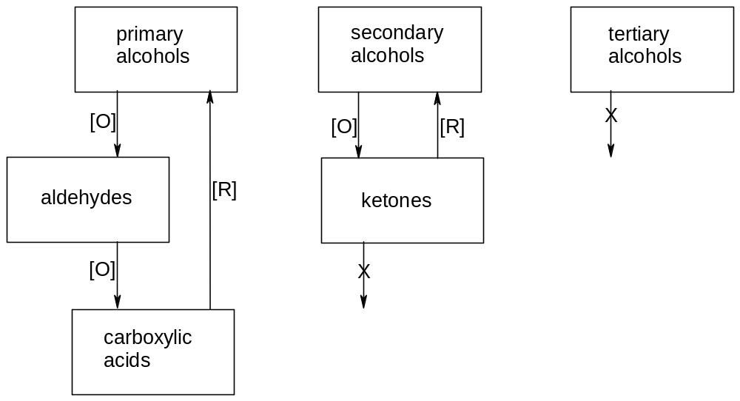

a) oxidation reactions

Carbonyls are formed by the oxidation of alcohols.

Partial oxidation of a primary alcohol results in the formation of an aldehyde.

Oxidation of a secondary alcohol results in the formation of a ketone.

Primary alcohols, secondary alcohols and aldehydes are oxidized using potassium dichromate (K₂Cr₂O₇) in sulphuric acid (H₂SO₄). Gentle warming is necessary to start the reaction.

When making an aldehyde, care must be taken to prevent further oxidation to the carboxylic acid. This is achieved by using distillation apparatus so that the aldehyde can be distilled off as soon as it is formed.

The orange Cr₂O₇²⁻ is reduced to the green Cr³⁺.

Simplified equations for these oxidation reactions can be written using the symbol [O] as the oxidant:

Primary alcohol → aldehyde
R-CH₂OH + [O] → R-CHO + H₂O

Secondary alcohol → ketone
R₁-CH(OH)-R₂ + [O] → R₁-CO-R₂ + H₂O

Aldehyde → carboxylic acid
R-CHO + [O] → R-COOH

The most important difference in the reactions of aldehydes and ketones is the fact that aldehydes can be readily oxidized to carboxylic acids but ketones are not readily oxidized. This is used as the basis for two important distinguishing tests between aldehydes and ketones.

Ammoniacal silver nitrate, [Ag(NH₃)₂]⁺, is known as Tollen's reagent. It is a mild oxidising agent:
[Ag(NH₃)₂]⁺(aq) + e → Ag(s) + 2NH₃(aq)

It can be reduced by aldehydes, oxidising them to carboxylic acids:
R-CHO + H₂O → RCOOH + 2H⁺(aq) + 2e

The overall equation for the reaction is:
R-CHO + 2[Ag(NH₃)₂]⁺ + H₂O → RCOOH + 2Ag + 4NH₃ + 2H⁺

Thus aldehydes give a grey precipitate or "silver mirror" if boiled with ammoniacal silver nitrate. This is a standard test for an aldehyde, since ketones cannot be oxidised in this way.

Fehling’s solution is an alkaline solution containing Cu²⁺ ions. It is a mild oxidizing agent:
2Cu²⁺ + 2e + 2OH⁻ → Cu₂O + H₂O

It is also reduced by aldehydes, and the overall equation for the reaction is:
R-CHO + 4OH⁻ + 2Cu²⁺ → R-COOH + Cu₂O + 2H₂O

The blue Cu²⁺ is reduced to the brick-red precipitate Cu₂O on gentle warming. This is another standard test for an aldehyde.

b) reduction reactions

Aldehydes and ketones can be reduced to primary and secondary alcohols respectively using the reducing agent sodium tetrahydroborate (III), NaBH₄.

Simplified equations for these reduction reactions can be written using the symbol [H] as the reductant:

Aldehyde → primary alcohol
R-CHO + 2[H] → R-CH₂OH

Ketone → Secondary alcohol
R₁-CO-R₂ + 2[H] → R₁-CH(OH)-R₂

Carboxylic acids cannot be reduced using NaBH₄ but can be reduced to primary alcohols using the stronger reducing agent LiAlH₄.

3. Nucleophilic addition

Carbonyls are unsaturated and can thus undergo addition reactions.

The C=O bond is polar so the carbon is a positive centre. Thus carbonyls can react with nucleophiles:


Carbonyls therefore tend to undergo nucleophilic addition.
Mechanism of nucleophilic addition:

Example 1: addition of HCN to make hydroxynitriles

NB
- HCN is a very poisonous gas. It is not safe to carry out this reaction in the laboratory. HCN is not stored, but made in situ by mixing KCN and HCl.
- KCN is also very poisonous but it is safer to store as it is a solid.

Hydrogen cyanide, HCN, is a nucleophile. It reacts with carbonyls as follows:

R₁-CO-R₂ + HCN → R₁-C(CN)(OH)-R₂
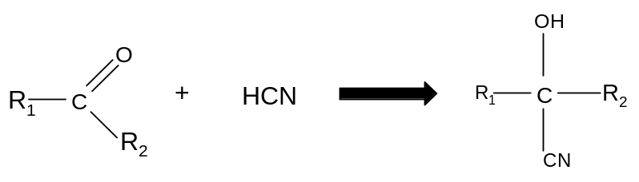
HCN is a very toxic gas, so is generated in situ:
KCN(s) + HCl(aq) → HCN(g) + KCl(aq)

The mechanism consists of three steps:

Step 1: the HCN is a weak acid and dissociates:

HCN → H⁺ + CN⁻

The CN⁻ behaves as a nucleophile.

Step 2: The nucleophile attacks the carbonyl:


Step 3: The O atom picks up the H⁺ ion:

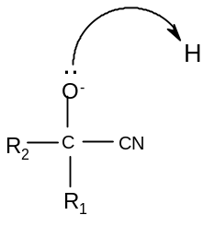

Eg propanal + HCN → 2-hydoxybutanenitrile
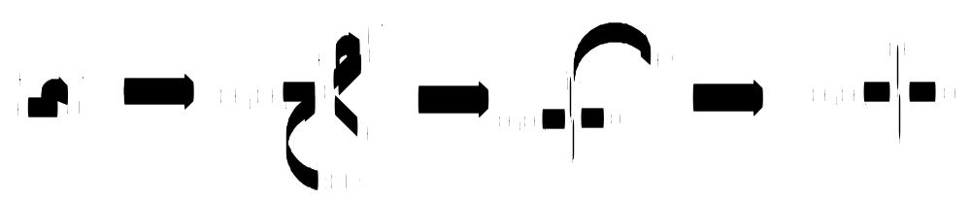

Example 2: reduction by NaBH₄ to make alcohols

The reduction of aldehydes and ketones as described above is another example of a nucleophilic addition reaction.
R₁-CO-R₂ + 2[H] → R₁-CH(OH)-R₂
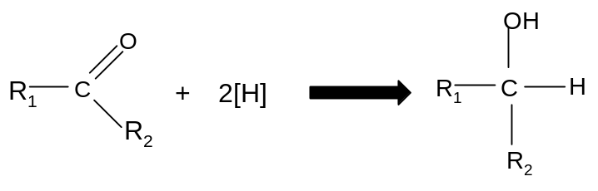
NaBH₄ contains hydrogen in a negative oxidation state, which can therefore behave as a nucleophile.

Step 1: the H⁻ ion attacks the δ⁺ carbon atom:
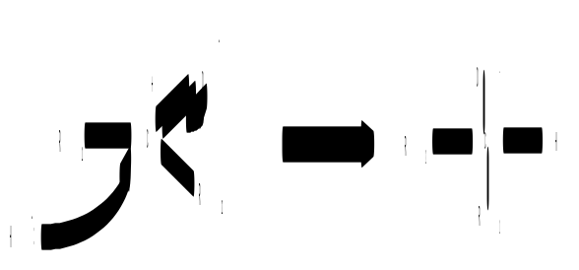
Step 2: the O⁻ pulls a H atom off a water molecule

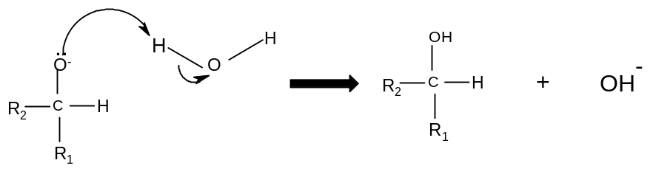

eg propanone + 2[H] → propan-2-ol

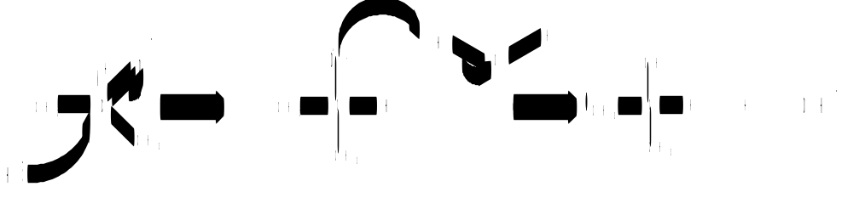

4. Summary of reactions of aldehydes and ketones

Type of reaction | Mechanism
1. oxidation (aldehydes only): aldehyde → carboxylic acid  reagents: potassium dichromate (K₂Cr₂O₇) in sulphuric acid (H₂SO₄)  conditions: warm under reflux  equation: R-CHO + [O] → R-COOH  observation: orange to green  to distinguish between aldehydes and ketones:  either:  add Fehling’s solution and heat  observation: blue solution to brick red precipitate  equation: R-CHO + 4OH⁻ + 2Cu²⁺ → R-COOH + Cu₂O + 2H₂O  or:  add Tollen’s reagent and heat  observation: colourless solution to silver mirror  equation: R-CHO + 2[Ag(NH₃)₂]⁺ + H₂O → RCOOH + 2Ag + 4NH₃ + 2H⁺ | n/a
2. reduction: carbonyl → alcohol  reagents: NaBH₄(aq)  conditions: room temperature  equation: R₁-CO-R₂ + 2[H] → R₁-CH(OH)-R₂ | Nucleophilic addition (required)
3. addition of HCN: carbonyl → hydroxynitrile  reagents: KCN and HCl(aq)  conditions: room temperature  equation: R₁-CO-R₂ + HCN → R₁-C(CN)(OH)-R₂ | Nucleophilic addition (required)

CARBOXYLIC ACIDS AND CARBOXYLATE SALTS

Carboxylic acids have the general formula C₂H_{2n}O₂ and contain the following functional group:
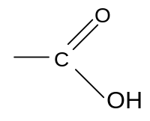

Eg methanoic acid ethanoic acid butanoic acid
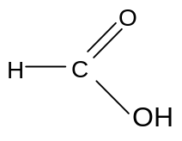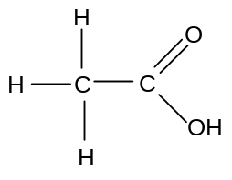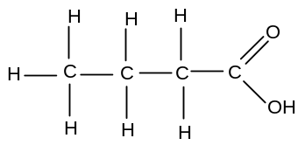

They can form hydrogen bonds with water, so most carboxylic acids with relatively short chains are highly soluble in water. They are often less soluble in non-polar solvents.

a) Reactions of carboxylic acids with bases

Carboxylic acids are weak acids; they dissociate partially in water to form carboxylate (or alkanoate) salts.

R-COOH(aq) + H₂O(l) == RCOO⁻(aq) + H₃O⁺(aq)

The ability of carboxylic acids to behave as acids is due to the relatively high stability of the R-COO⁻ anion. These anions are known as carboxylate or alkanoate ions and have the following structure:

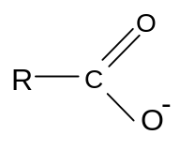
The ion has a delocalised system which accounts for its relatively high stability.

Nevertheless these acids are weak acids and will only dissociate partially in water.

In the presence of stronger bases such as carbonate ions or hydroxide ions, the acid will dissociate completely:

i) with sodium hydroxide

Carboxylic acids react with sodium hydroxide to produce the sodium salt and water:

R-COOH(aq) + NaOH(aq) → R-COO⁻Na⁺(aq) + H₂O(l)

Eg ethanoic acid + sodium hydroxide → sodium ethanoate + water
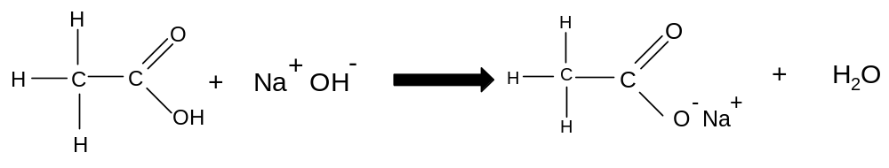
ii) with sodium carbonate

Carboxylic acids react with sodium carbonate to produce the sodium salt, carbon dioxide and water:

2R-COOH(aq) + Na₂CO₃(aq) → 2R-COO⁻Na⁺(aq) + CO₂(g) + H₂O(l)

eg 2C₂H₅COOH(aq) + Na₂CO₃(aq) → 2 C₂H₅COO⁻Na⁺(aq) + CO₂(g) + H₂O(l)

Thus when carboxylic acids are treated with sodium carbonate, a colourless gas is evolved which turns limewater milky. This is the standard test for a carboxylic acid.

b) Reaction of carboxylate salts with acids

Since these salts are the salts of weak acids, they have basic properties. Most have a pH of between 8 and 9:

R-COO⁻(aq) + H₂O(l) == R-COOH(aq) + OH⁻(aq)

They react completely with strong acids to form the original carboxylic acid:

R-COO⁻(aq) + H⁺(aq) → R-COOH(aq)

Eg CH₃COO⁻Na⁺(aq) + HCl(aq) → CH₃COOH(aq) + NaCl(l)
sodium ethanoate ethanoic acid

Carboxylate salts can readily be converted into carboxylic acids by addition of a strong acid such as hydrochloric acid.

c) Reaction of carboxylic acids with alcohols

If a carboxylic acid and an alcohol are heated under reflux with concentrated H₂SO₄, a condensation reaction takes place and an ester is formed:

Carboxylic acid + alcohol == ester + H₂O
R₁-COOH + R₂OH == R₁-COOR₂ + H₂O

This reaction is known as esterification. Esterifcation is an example of condensation; a reaction in which two or more organic molecules join together to form a single large molecule, and in so doing give off a small molecule such as HCl or H₂O.

Eg
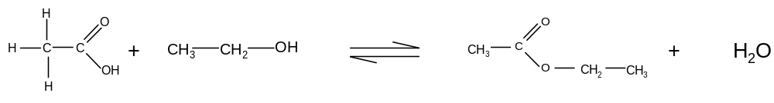
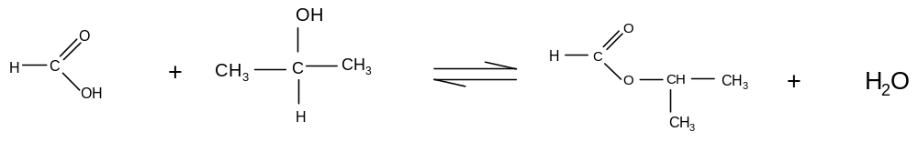
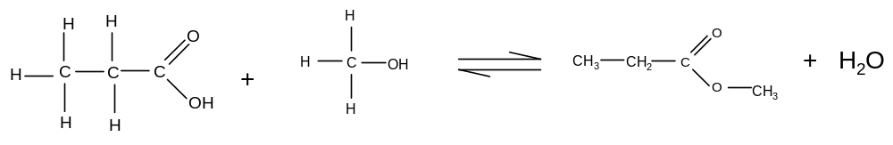
The H₂SO₄ acts as a catalyst. The alcohol behaves as a nucleophile, and the lone pair on the O attacks the positive centre on the carboxylic acid:
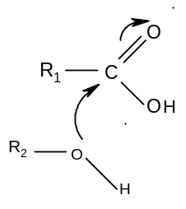
This reaction is reversible and reaches an equilibrium. The equilibrium constant for the reaction has a value of approximately 4, indicating that about 70% of the reactants are converted into products at equilibrium.

d) Summary of reactions of carboxylic acids and their salts

Type of reaction | Mechanism
1. acid-base  a) carboxylic acids with sodium hydroxide  reagent: NaOH  conditions: room temperature  equation: R-COOH(aq) + NaOH(aq) → R-COO⁻Na⁺(aq) + H₂O(l)  b) carboxylic acids with sodium carbonate  reagent: Na₂CO₃  conditions: room temperature  equation: 2R-COOH(aq) + Na₂CO₃(aq) → 2R-COO⁻Na⁺(aq) + CO₂(g) + H₂O(l)  observations: colourless gas evolved which turns limewater milky  c) carboxylate salts with acids  reagent: HCl(aq)  conditions: room temperature  equation: R-COO⁻(aq) + H⁺(aq) → R-COOH(aq) | n/a
2. esterification  reagents: any alcohol, concentrated sulphuric acid catalyst  conditions: heat and reflux  equation: R₁-COOH + R₂OH == R₁-COOR₂ + H₂O | Nucleophilic addition/  Elimination  (not required)

ESTERS

Esters are made when carboxylic acids and alcohols are heated together under reflux in the presence of a strong acid catalyst as described above. They have the same general formula (CHO) as carboxylic acids and contain the following functional group:
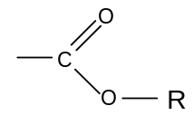
Eg
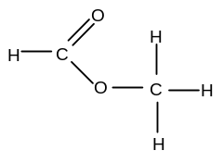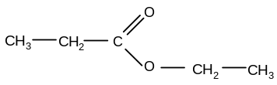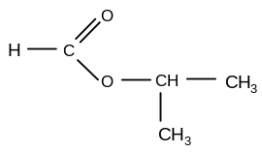
methyl methanoate ethyl propanoate methylethyl methanoate

a) Properties and uses of esters

Esters have pleasant, often sweet smells. They are widely used as food flavourings for this reason (eg ethyl methanoate gives raspberry flavour and ethyl butanoate gives pear flavour).

This sweet smell can also be used to test for the presence of carboxylic acids and alcohols; a carboxylic acid will give a sweet smell if heated with ethanol and a strong acid, and an alcohol will give a sweet smell if heated with ethanoic acid and a strong acid.

Esters are also used as plasticizers. They can be added to polymers to make them less rigid and more flexible. Plasticiser molecules weaken the intermolecular forces between the polymer chains.

Esters are also used as solvents for organic compounds such as nail varnish. The ester evaporates easily, leaving the solute behind.

b) Hydrolysis of esters

i) acid hydrolysis

Since the esterification reaction is reversible, it follows that if an ester is heated under reflux with concentrated H₂SO₄, a carboxylic acid and an alcohol will be formed in a reversible reaction:

R₁-COOR₂ + H₂O == R₁-COOH + R₂OH

Eg ethyl ethanoate + H₂O == ethanoic acid + ethanol
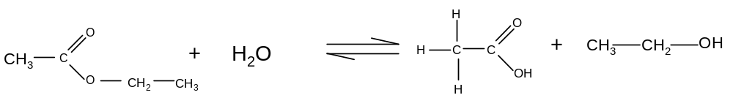

Eg methyl propanoate + H₂O == propanoic acid + methanol
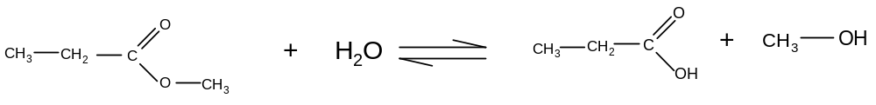

Eg propyl methanoate + H₂O == methanoic acid + propan-1-ol
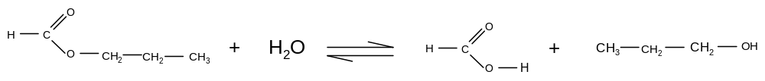

This reaction is known as ester hydrolysis. It does not go to completion but reaches equilibrium with only approximately 30% of the ester hydrolysed. It does not therefore give a very good yield of the carboxylic acid or the alcohol.

ii) alkaline hydrolysis (saponification)

If an ester is heated under reflux with a strong alkali such as NaOH, a carboxylate salt and an alcohol are formed:

R₁-COOR₂ + NaOH == R₁-COO⁻Na⁺ + R₂OH

Eg ethyl ethanoate + NaOH(aq) → sodium ethanoate + ethanol
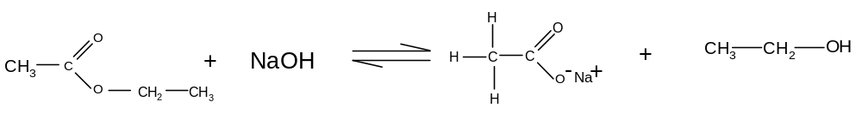

Eg methyl propanoate + NaOH(aq) → sodium propanoate + methanol
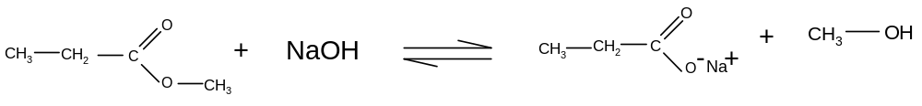

Eg propyl methanoate + NaOH(aq) → sodium methanoate + propan-1-ol
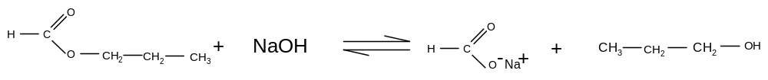

This reaction is known as alkaline hydrolysis. It is also known as saponification.
It is not readily reversible, so results in a better yield of the alcohol and carboxylate than the acid hydrolysis of the same ester.

The NaOH in this reaction is not a catalyst; it is a reactant. The equilibrium can thus be moved further to the right by using the NaOH in excess.

Saponification is thus a more efficient way of hydrolysing an ester than acid hydrolysis, since it results in a much better yield.

After the mixture is cooled, the carboxylate salt can be readily converted to the carboxylic acid by acidifying the mixture.

R-COO⁻(aq) + H⁺(aq) → R-COOH(aq)

This means that even if you want a carboxylic acid as your final product, it is better to hydrolyse the ester in alkaline conditions first and then acidify the mixture afterwards.

c) naturally occurring fats and oils

Naturally occurring fats and oils are in fact esters. They have the general formula:

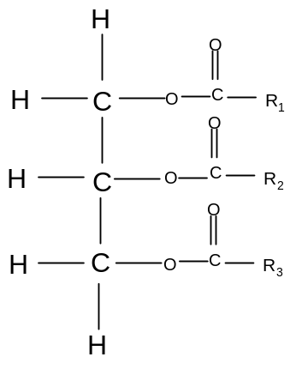R = C₁₃H₂₇, C₁₅H₃₁, C₁₇H₃₅ , or C₁₉H₃₉

They contain three ester groups. These esters are hydrolysed in the acidic conditions of the stomach and can be broken down into the constituent acid and alcohol. They can also be hydrolysed artificially in alkaline conditions.

i) acid hydrolysis of fats

During digestion, some fats are broken down into the constituent parts. The reaction is catalysed by an enzyme called lipase and the acidic conditions of the stomach:

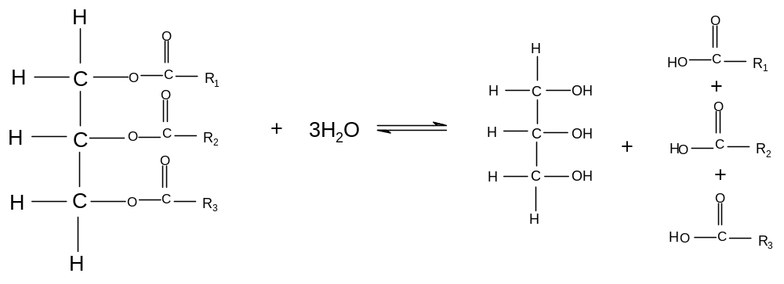
The products of this hydrolysis are propan-1,2,3–tri-ol (more commonly known as glycerol) and three long-chain carboxylic acids (generally known as fatty acids).

So the hydrolysis of a fat or oil molecule in the stomach produces glycerol and three fatty acid molecules. The formula for a typical fatty acid molecule would be C₁₇H₃₅COOH. Glycerol is used by the body to make glucose for respiration (which is why fats are good energy sources) and fatty acids are used to make cell membranes (which is why fats are essential for healthy tissue growth).

ii) alkaline hydrolysis of fats (saponification)

Fats and oils are hydrolysed commercially in alkaline conditions. The products are glycerol and the salts of the fatty acids:

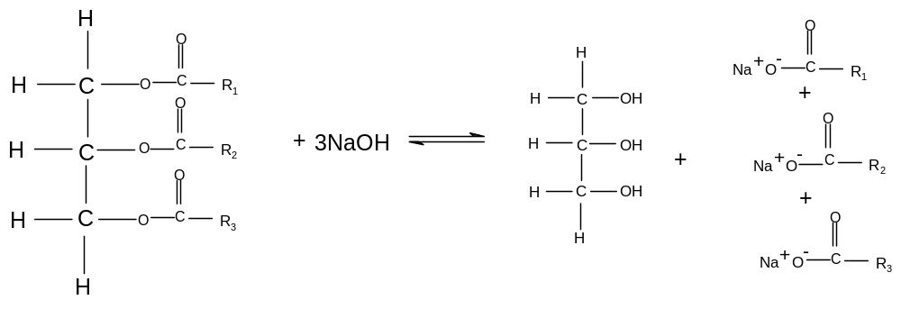

The salts of the long-chain fatty acids are known as soaps. They are extremely useful as they help oil and water mix together. Glycerol is a useful by-product of this reaction as it can be used to make pharmaceuticals and cosmetics.

So the alkaline hydrolysis of fats and oils produces soap, which usually has the formula C₁₇H₃₅COO⁻Na⁺. Glycerol is also formed as a useful by-product.

Soap molecules have a polar end, which is the carboxylate end, which attracts water and other hydrophilic groups. They also have a non-polar end, which is the long-chain hydrocarbon end, which attracts oils and other hydrophobic groups. The same molecule is thus attracted to aqueous species and oily species, thus enabling them to mix. This means that oil will come off skin (or cooking utensils) into water which contains soap.

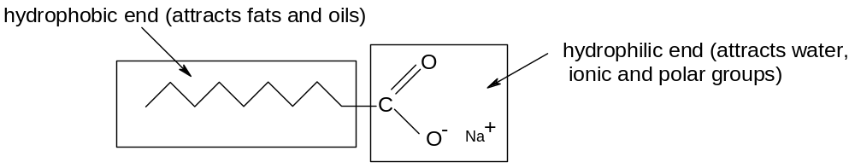

iii) making biodiesel

Biodiesel is a mixture of methyl esters of long chain fatty acids.

It is made by hydrolysing naturally occurring fats or oils (as described above) to make fatty acids.

The fatty acids can then be mixed with methanol in the presence of a suitable catalyst to make a methyl ester. This is an esterification reaction.

Eg C₁₇H₃₅COOH + CH₃OH == C₁₇H₃₅COOCH₃ + H₂O

Biodiesel is a renewable fuel because it is made from vegetable oil, which can be produced quickly by growing crops such as rape.

d) summary of reactions of esters

Type of reaction | Mechanism
hydrolysis  a) acid hydrolysis  reagent: concentrated H₂SO₄  conditions: heat under reflux  equation: R₁-COOR₂ + H₂O == R₁-COOH + R₂OH  b) alkaline hydrolysis (saponification)  reagent: NaOH(aq)  conditions: heat under reflux  equation: R₁-COOR₂ + NaOH == R₁-COO⁻Na⁺ + R₂OH | n/a

ACYL CHLORIDES AND ACID ANHYDRIDES

Carboxlyic acids will react with bases and with alcohols, but are generally unreactive otherwise. Although the δ^{+ve} C atom can attract nucleophiles, the stability of the –COOH group means that these reactions do not take place readily.

Nucleophilic attack at the C atom will take place if the carboxylic acid is first converted into a more reactive derivative. Two such derivatives are acyl chlorides and acid anhydrides.

a) structure of acyl chlorides and acid anhydrides

Acyl chlorides contain the following functional group:
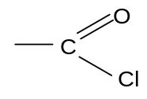
Eg
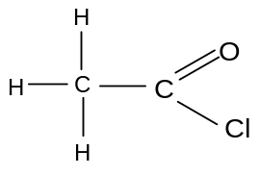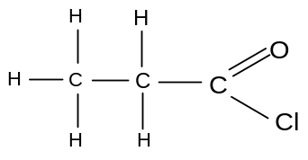
ethanoyl chloride propanoyl chloride

The carbon atom is attached to two electronegative atoms and so is very δ^{+ve}. It attracts nucleophiles readily:
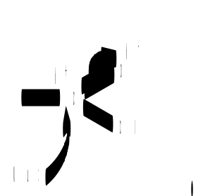

Acid anhydrides contain the following functional group:
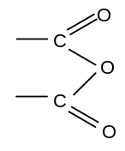
Eg
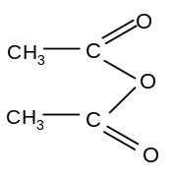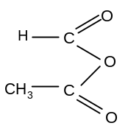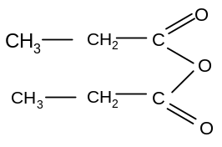
ethanoic anhydride methanoic ethanoic anhydride propanoic anhydride

Again, the carbon atom is attached to two electronegative atoms, is very δ^{+ve} and attracts nucleophiles readily:

Acyl chlorides and acid anhydrides both react readily with nucleophiles.

b) mechanism: nucleophilic addition-elimination

Acyl chlorides react by a mechanism called nucleophilic addition-elimination.

When an acyl chloride is attacked by a nucleophile, addition occurs and the π–bond is broken:
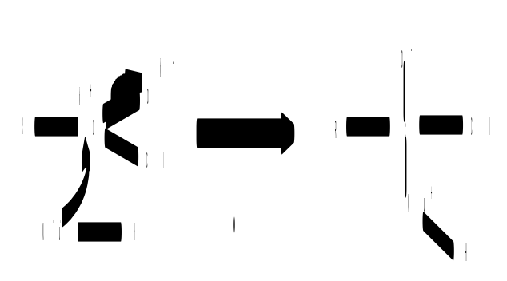
However, the C-Cl bond then breaks and the π–bond is reformed. The extra H on the nucleophile is also lost:
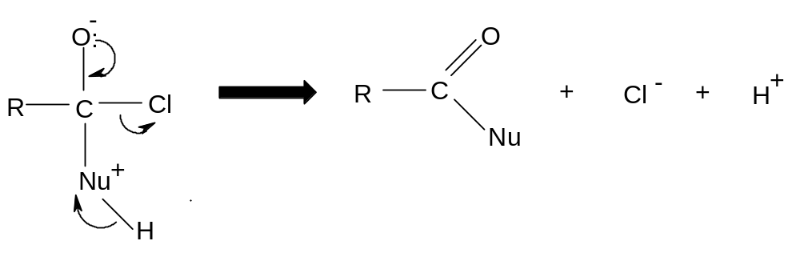
The chloride ion, or another nucleophile may combine with the free proton.

Acyl chlorides and acid anhydrides react with water, ammonia, alcohols and primary amines by this mechanism. This reaction is also known as acylation.

c) acylation reactions of acyl chlorides

i) with water

Acyl chlorides react with water violently. White fumes of HCl can be clearly seen:

R-COCl + H₂O → R-COOH + HCl

The organic product is a carboxylic acid.

The mechanism is nucleophilic addition-elimination:
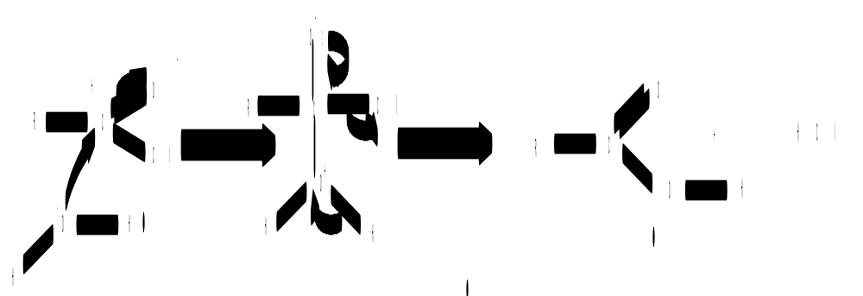

example: 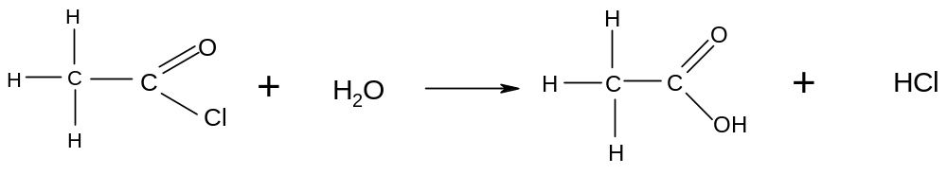

ii) with ammonia

Acyl chlorides also react with ammonia violently. White fumes of HCl can be clearly seen:

R-COCl + NH₃ → R-CONH₂ + HCl
In excess ammonia, the left-over NH₃ and the HCl may react:
R-COCl + 2NH₃ → R-CONH₂ + NH₄Cl

The organic product is an amide.

The mechanism is nucleophilic addition-elimination:
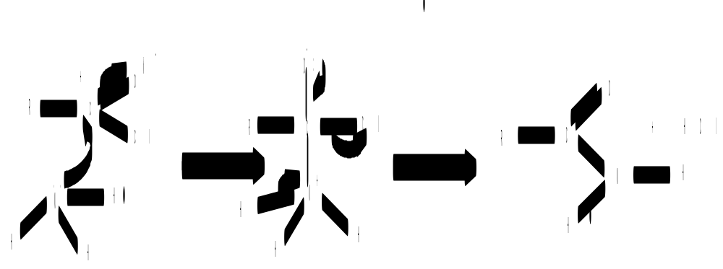

example: 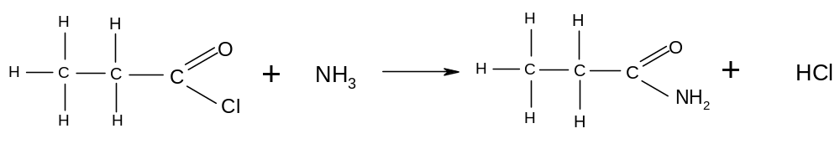or in excess ammonia:

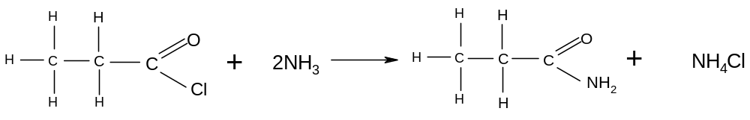
iii) with alcohols

Acyl chlorides react violently with alcohols. White fumes of HCl can be seen:

R₁-COCl + R₂-OH → R₁-COOR₂ + HCl

The organic product is an ester.

The mechanism is nucleophilic addition-elimination:
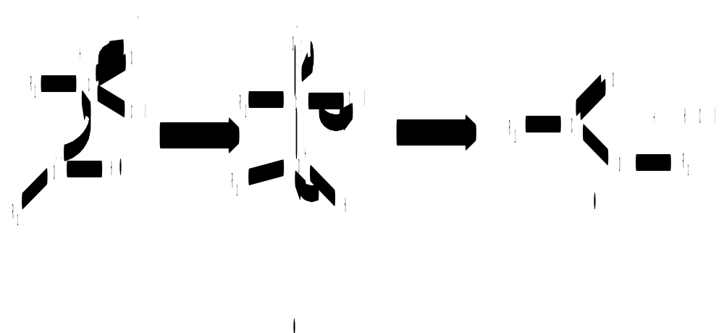
example:
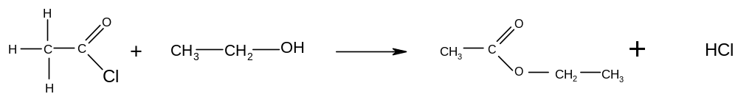

iv) with primary amines

Acyl chlorides react vigorously with primary amines. White fumes of HCl can be seen:

R₁-COCl + R₂-NH₂ → R₁-CONHR₂ + HCl

In excess amine, the left-over amine can react with the HCl:
R₁-COCl + 2R₂-NH₂ → R₁-CONHR₂ + R₂-NH₃Cl
The organic product is an N-substituted amide.

The mechanism is nucleophilic addition-elimination:
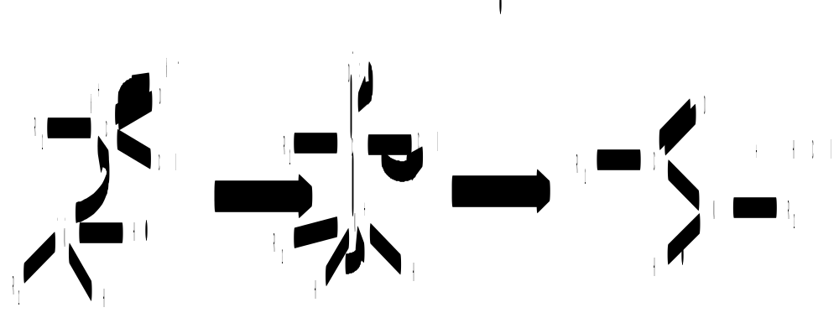

example:
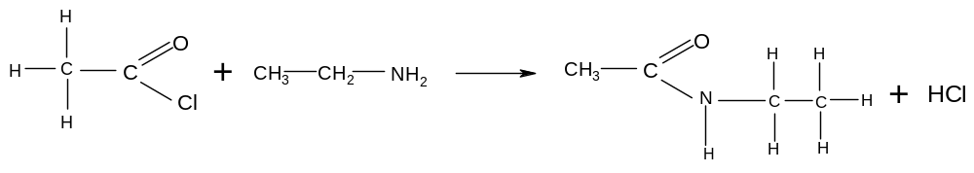
or, in excess amine:
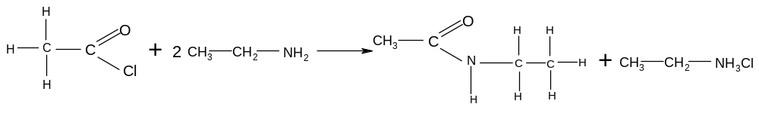
d) acylation reactions of acid anhydrides

Acid anhydrides react in the same way as acyl chlorides. They react with water, ammonia, alcohols and primary amines. The mechanism is also nucleophilic addition-elimination.

The reactions are much slower than the acyl chloride reactions, and do not produce the toxic gas HCl but produce a carboxylic acid instead.

Commercially, acid anhydrides are therefore used preferentially to acyl chlorides in acylation reactions; the reactions are easier to control and they do not produce a toxic gas.

i) with water

Acid anhydrides react with water slowly when the mixture is warmed. Two carboxylic molecules are produced.

R₁-COOCO-R₂ + H₂O → R₁-COOH + R₂-COOH

Example:
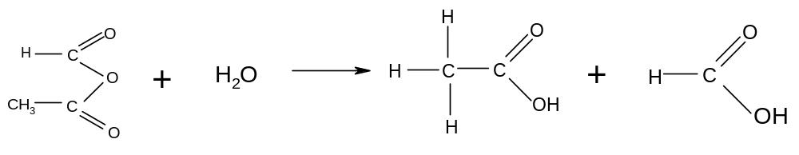

ii) with ammonia

Acid anhydrides react with ammonia slowly when the mixture is warmed. An amide and a carboxylic acid are produced.

R₁-COOCO-R₂ + NH₃ → R₁-CONH₂ + R₂-COOH

Example:
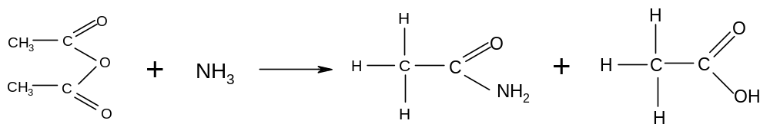

iii) with alcohols

Acid anhydrides react with alcohols on gentle heating to produce esters. A carboxylic acid is also produced.

R₁-COOCO-R₂ + R₃-OH → R₁-COO-R₃ + R₂-COOH

Example:
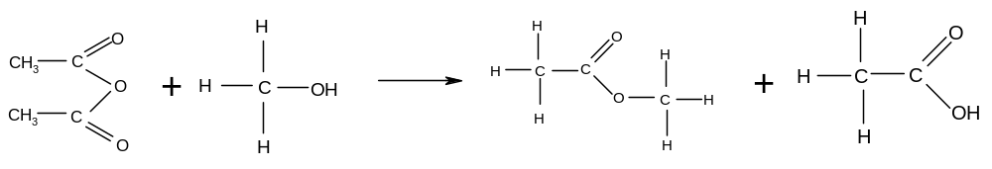

iv) with primary amines

Acid anhydrides react with primary amines on gentle heating to produce N-substituted amides. A carboxylic acid is also produced.

R₁-COOCO-R₂ + R₃-NH₂ → R₁-CONH-R₃ + R₂-COOH

Example:
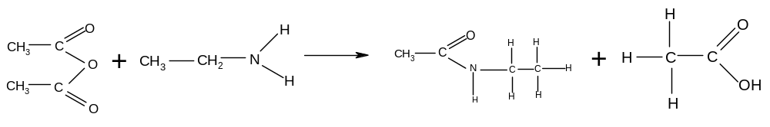

e) preparation of aspirin

Aspirin is an ester with the following formula:

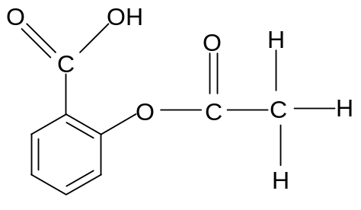

It is made be reacting the -OH group on 2-hydroxybenzoic acid with either ethanoic acid, ethanoyl chloride or ethanoic anhydride.

The reaction with ethanoic acid needs strongly acidic conditions, heat and reflux and only goes to equilibrium.

The reaction with ethanoyl chloride is violent, difficult to control and produces the toxic gas hydrogen chloride.

The reaction with ethanoic anhydride is reasonably fast when heated gently and does not produce toxic by-products. It is therefore the chosen method for the preparation of aspirin.

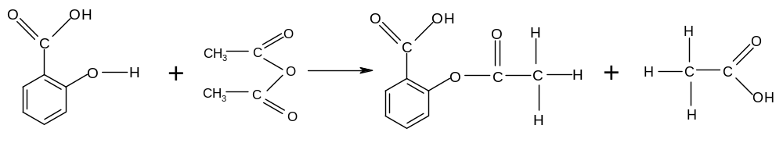

f) summary of reactions of acyl chlorides and acid anhydrides

Type of reaction | Mechanism
1. acylation using acyl chlorides  a) with water (to make carboxylic acids)  conditions: room temperature  equation: R-COCl + H₂O → R-COOH + HCl  observation: white misty fumes  b) with ammonia (to make amides)  conditions: room temperature  equation: R-COCl + 2NH₃ → R-CONH₂ + NH₄Cl  observation: white misty fumes  c) with alcohols (to make esters)  conditions: room temperature  equation: R₁-COCl + R₂-OH → R₁-COOR₂ + HCl  observation: white misty fumes  d) with primary amines (to make N-substituted amides)  conditions: room temperature  equation: R₁-COCl + 2R₂-NH₂ → R₁-CONHR₂ + R₂-NH₃Cl  observation: white misty fumes | Nucleophilic addition-elimination  (required)
2. acylation using acid anhydrides  a) with water (to make carboxylic acids)  conditions: room temperature  equation: R₁-COOCO-R₂ + H₂O → R₁-COOH + R₂-COOH  observation: no visible change  b) with ammonia (to make amides)  conditions: room temperature  equation: R₁-COOCO-R₂ + NH₃ → R₁-CONH₂ + R₂-COOH  observation: no visible change  c) with alcohols (to make esters)  conditions: room temperature  equation: R₁-COOCO-R₂ + R₃-OH → R₁-COO-R₃ + R₂-COOH  observation: no visible change  d) with primary amines (to make N-substituted amides)  conditions: room temperature  equation: R₁-COOCO-R₂ + R₃-NH₂ → R₁-CONH-R₃ + R₂-COOH  observation: no visible change | Nucleophilic addition-elimination  (not required)

